

DESIGN AND ANALYSIS OF ALGORITHMS
LAB WORKBOOK
WEEK - 2

NAME : SANTHOSH A
ROLL NUMBER : CH.SC.U4CSE24142
CLASS : CSE-B
Question 1: Write a C program that reads N integers from the user and sorts them in ascending order using Bubble Sort.
CODE:
//Write a C program that reads N integers from the user and sorts them in ascending order using Bubble Sort
// CH.SC.U4CSE24142 - SANTHOSH A
#include <stdio.h>
void bubbleSort(int arr[], int n) {
int i, j, temp;
for (i = 0; i < n - 1; i++) {
for (j = 0; j < n - i - 1; j++) {
if (arr[j] > arr[j + 1]) {
temp = arr[j];
arr[j] = arr[j + 1];
arr[j + 1] = temp;
}
}
}
}
int main() {
printf("CH.SC.U4CSE24142 - SANTHOSH A\n");
int num, i;
printf("Enter the number of integers: ");
scanf("%d", &num);
int arr[num];
printf("Enter %d integers:\n", num);
for (i = 0; i < num; i++) {
scanf("%d", &arr[i]);
}
bubbleSort(arr, num);
printf("Sorted integers in ascending order:\n");
for (i = 0; i < num; i++) {
printf("%d ", arr[i]);
}
return 0;
}
OUTPUT:
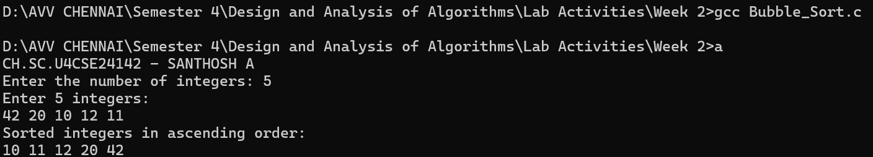
Space Complexity: O(1)
Time Complexity: O(N²)
Justification:
- Uses two nested loops to repeatedly compare adjacent elements. Hence the Space Complexity is O(1).
- Uses two nested loops to repeatedly compare adjacent elements. Hence its Time Complexity is O(N²).
Question 2: Create a C program that implements Selection Sort to sort an array of integers.
CODE:
//Create a C program that implements Selection Sort to sort an array of integers.
// CH.SC.U4CSE24142 - SANTHOSH A
#include <stdio.h>
#include <stdlib.h>
void selectionSort(int arr[], int n) {
int i, j, min_idx, temp;
for (i = 0; i < n - 1; i++) {
min_idx = i;
for (j = i + 1; j < n; j++) {
if (arr[j] < arr[min_idx]) {
min_idx = j;
}
}
temp = arr[min_idx];
arr[min_idx] = arr[i];
arr[i] = temp;
}
}
int main() {
printf("CH.SC.U4CSE24142 - SANTHOSH A\n");
int n;
printf("Enter the number of integers: ");
scanf("%d", &n);
int arr[n];
printf("Enter %d integers:\n", n);
for (int i = 0; i < n; i++) {
scanf("%d", &arr[i]);
}
selectionSort(arr, n);
printf("Sorted array: \n");
for (int i = 0; i < n; i++) {
printf("%d ", arr[i]);
}
printf("\n");
return 0;
}
OUTPUT:
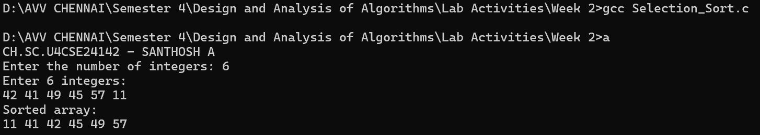

Space Complexity: O(1)
Time Complexity: O(N²)
Justification:
- No additional memory is used apart from a temporary variable. Hence the Space Complexity is O(1).
- The outer loop runs n-1 times and the inner loop scans the remaining elements to find the minimum value, regardless of input order. Hence the Time Complexity is O(N²).
Question 3: Write a C program that performs Insertion Sort on an array of integers.
CODE:
//Write a C program that performs Insertion Sort on an array of integers.
// CH.SC.U4CSE24142 - SANTHOSH A
#include <stdio.h>
void insertionSort(int arr[], int n) {
int i, key, j;
for (i = 1; i < n; i++) {
key = arr[i];
j = i - 1;
while (j >= 0 && arr[j] > key) {
arr[j + 1] = arr[j];
j = j - 1;
}
arr[j + 1] = key;
}
}
int main() {
printf("CH.SC.U4CSE24142 - SANTHOSH A\n");
int n, i;
printf("Enter the number of integers: ");
scanf("%d", &n);
int arr[n];
printf("Enter %d integers:\n", n);
for (i = 0; i < n; i++) {
scanf("%d", &arr[i]);
}
insertionSort(arr, n);
printf("Sorted array: \n");
for (i = 0; i < n; i++) {
printf("%d ", arr[i]);
}
printf("\n");
return 0;
}
OUTPUT:
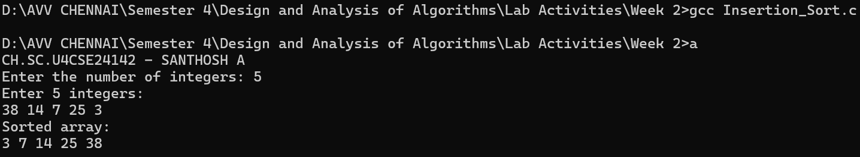
Space Complexity: O(1)
Time Complexity: O(N²)
Justification:
- Uses only a single variable to store the current element.Hence the Space Complexity is O(1).
- The while loop may compare the current element with all previous elements in the worst case. Hence the Time Complexity is O(N²).
Question 4: Write a C program to sort a given set of integers using Heap Sort based on Max Heap.
CODE:
//Write a C program to sort a given set of integers using Heap Sort based on Max Heap
//CH.SC.U4CSE24142 - SANTHOSH A
#include <stdio.h>
void heapify(int arr[], int n, int i) {
int largest = i;
int left = 2 * i + 1;
int right = 2 * i + 2;
if (left < n && arr[left] > arr[largest])
largest = left;
if (right < n && arr[right] > arr[largest])
largest = right;
if (largest != i) {
int temp = arr[i];
arr[i] = arr[largest];
arr[largest] = temp;
heapify(arr, n, largest);
}
}
void heapSort(int arr[], int n) {
for (int i = n / 2 - 1; i >= 0; i--) {
heapify(arr, n, i);
}
for (int i = n - 1; i > 0; i--) {
int temp = arr[0];
arr[0] = arr[i];
arr[i] = temp;
heapify(arr, i, 0);
}
}
int main() {
printf("CH.SC.U4CSE24142 - SANTHOSH A\n");
int n;
printf("Enter number of elements: ");
scanf("%d", &n);
int arr[n];
printf("Enter %d integers:\n", n);
for (int i = 0; i < n; i++) {
scanf("%d", &arr[i]);
}
heapSort(arr, n);
printf("Sorted array:\n");
for (int i = 0; i < n; i++) {
printf("%d ", arr[i]);
}
printf("\n");
return 0;
}
OUTPUT:
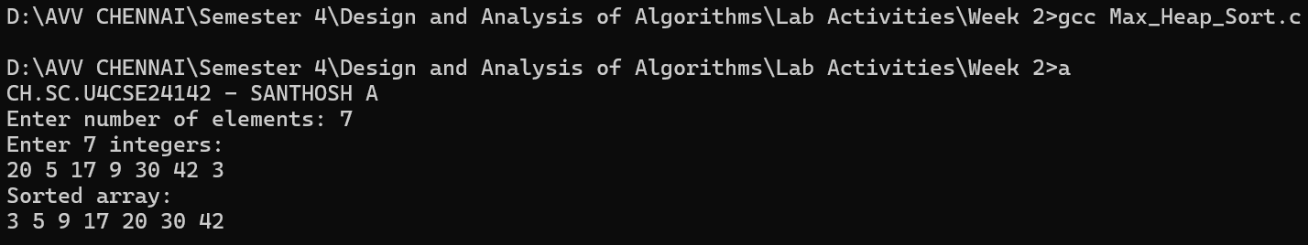
Space Complexity: O(1)
Time Complexity: O(N log N)
Justification:
- The sorting is done in-place using the same array with only a few temporary variables. Hence the Space Complexity is O(1).
- Building the max heap takes O(n) time and heapify is called n times, each taking O(log n). Hence the Time Complexity is O(N log N).
Question 5: Write a C program to sort a given set of integers using Heap Sort based on Min Heap.
CODE:
//Write a C program to sort a given set of integers using Heap Sort based on Min Heap.
// CH.SC.U4CSE24142 - SANTHOSH A
#include <stdio.h>
void heapify(int arr[], int n, int i) {
int smallest = i;
int left = 2 * i + 1;
int right = 2 * i + 2;
if (left < n && arr[left] < arr[smallest])
smallest = left;
if (right < n && arr[right] < arr[smallest])
smallest = right;
if (smallest != i) {
int temp = arr[i];
arr[i] = arr[smallest];
arr[smallest] = temp;
heapify(arr, n, smallest);
}
}
void heapSort(int arr[], int n) {
for (int i = n / 2 - 1; i >= 0; i--) {
heapify(arr, n, i);
}
for (int i = n - 1; i > 0; i--) {
int temp = arr[0];
arr[0] = arr[i];
arr[i] = temp;
heapify(arr, i, 0);
}
}
int main() {
printf("CH.SC.U4CSE24142 - SANTHOSH A\n");
int n;
printf("Enter number of elements: ");
scanf("%d", &n);
int arr[n];
printf("Enter %d integers:\n", n);
for (int i = 0; i < n; i++) {
scanf("%d", &arr[i]);
}
heapSort(arr, n);
printf("Sorted array (Descending Order):\n");
for (int i = 0; i < n; i++) {
printf("%d ", arr[i]);
}
printf("\n");
return 0;
}

OUTPUT:
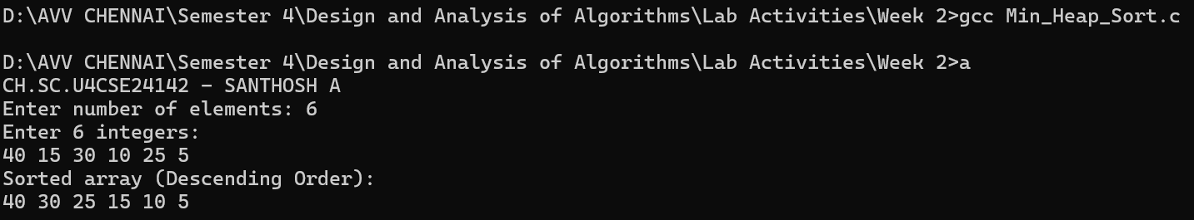
Space Complexity: O(1)
Time Complexity: O(N log N)
Justification:
- The sorting is done in-place using the same array with only a few temporary variables. Hence the Space Complexity is O(1).
- Building the min heap takes O(n) time and heapify is called n times, each taking O(log n). Hence the Time Complexity is O(N log N).

Question 6: Write a C program that implements Bucket Sort to sort an array of floating-point numbers
CODE:
//Write a C program that implements Bucket Sort to sort an array of floating-point numbers
#include <stdio.h>
#include <stdlib.h>
void insertionSort(float arr[], int n) {
for (int i = 1; i < n; i++) {
float key = arr[i];
int j = i - 1;

while (j >= 0 && arr[j] > key) {
arr[j + 1] = arr[j];
j--;
}
arr[j + 1] = key;
}
}
void bucketSort(float arr[], int n) {
float buckets[n][n];
int bucketCount[n];
for (int i = 0; i < n; i++) {
bucketCount[i] = 0;
}
for (int i = 0; i < n; i++) {
int bucketIndex = arr[i] * n;
buckets[bucketIndex][bucketCount[bucketIndex]] = arr[i];
bucketCount[bucketIndex]++;
}
for (int i = 0; i < n; i++) {
if (bucketCount[i] > 0) {
insertionSort(buckets[i], bucketCount[i]);
}
}
int index = 0;
for (int i = 0; i < n; i++) {
for (int j = 0; j < bucketCount[i]; j++) {
arr[index++] = buckets[i][j];
}
}
}
int main() {
int n;
printf("CH.SC.U4CSE24142 - SANTHOSH A\n");
printf("Enter number of floating-point values: ");
scanf("%d", &n);
float arr[n];
printf("Enter %d numbers (between 0 and 1):\n", n);
for (int i = 0; i < n; i++) {
scanf("%f", &arr[i]);
}
bucketSort(arr, n);
printf("\nSorted array:\n");
for (int i = 0; i < n; i++) {
printf("%0.2f ", arr[i]);
}
printf("\n");
return 0;
}
OUTPUT:
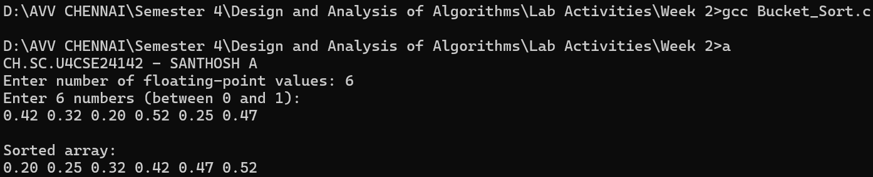
Space Complexity: O(N²)
Time Complexity: O(N²)
Justification:
- In the worst case, all elements may fall into a single bucket and are sorted using insertion sort. Hence the Space Complexity is O(N²).
- In the worst case, all elements may fall into a single bucket and are sorted using insertion sort. Hence the Time Complexity is O(N²).
Question 7: Write a C program to perform Breadth First Search (BFS) on a graph using an adjacency matrix.
CODE:
//Write a C program to perform Breadth First Search (BFS) on a graph using an adjacency matrix.
// CH.SC.U4CSE24142 - SANTHOSH A
#include <stdio.h>
int graph[10][10], visited[10];
int n;
void bfs(int start) {
int queue[10], front = 0, rear = 0;
queue[rear++] = start;
visited[start] = 1;
printf("BFS Traversal: ");
while (front < rear) {
int v = queue[front++];
printf("%d ", v);
for (int i = 0; i < n; i++) {
if (graph[v][i] == 1 && visited[i] == 0) {
queue[rear++] = i;
visited[i] = 1;
}
}
}
}
int main() {
printf("CH.SC.U4CSE24142 - SANTHOSH A\n");
int start;
printf("Enter number of vertices: ");
scanf("%d", &n);
printf("Enter adjacency matrix:\n");
for (int i = 0; i < n; i++) {
visited[i] = 0;
for (int j = 0; j < n; j++) {
scanf("%d", &graph[i][j]);
}
}
printf("Enter starting vertex: ");
scanf("%d", &start);
bfs(start);
return 0;
}
OUTPUT:
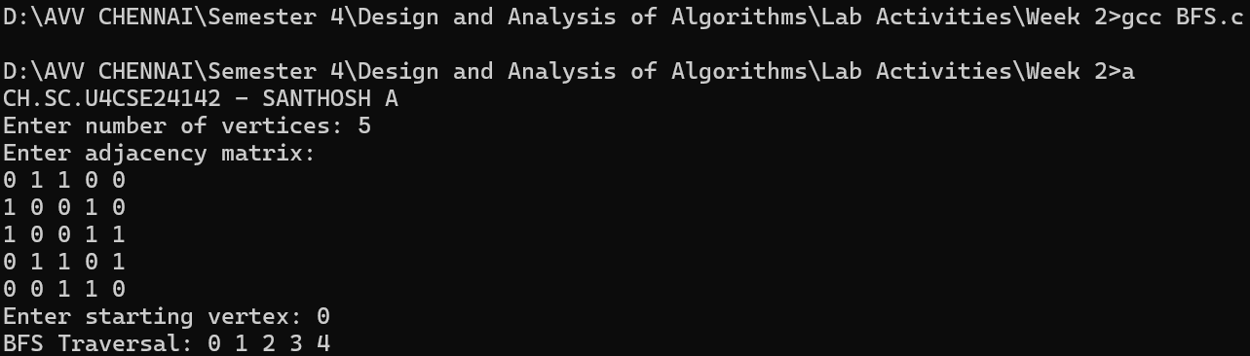
Space Complexity: O(V)
Time Complexity: O(V+E)
Justification:
- The queue can store upto V vertices in the worst case. Hence the Space Complexity is O(V).
- BFS visits every vertex once and checks every edge once while exploring adjacency lists. Hence the Time Complexity is O(V+E).

Question 8: Write a C program to perform Depth First Search (DFS) on a graph using an adjacency matrix.
CODE:
// Write a C program to perform Depth First Search (DFS) on a graph using an adjacency matrix.
// CH.SC.U4CSE24142 - SANTHOSH A
#include <stdio.h>
int graph[10][10], visited[10];
int n;
void dfs(int v) {
visited[v] = 1;
printf("%d ", v);
for (int i = 0; i < n; i++) {
if (graph[v][i] == 1 && visited[i] == 0) {
dfs(i);
}
}
}
int main() {
printf("CH.SC.U4CSE24142 - SANTHOSH A\n");
int start;
printf("Enter number of vertices: ");
scanf("%d", &n);
printf("Enter adjacency matrix:\n");
for (int i = 0; i < n; i++) {
visited[i] = 0;
for (int j = 0; j < n; j++) {
scanf("%d", &graph[i][j]);
}
}
printf("Enter starting vertex: ");
scanf("%d", &start);
printf("DFS Traversal: ");
dfs(start);
return 0;
}

OUTPUT:
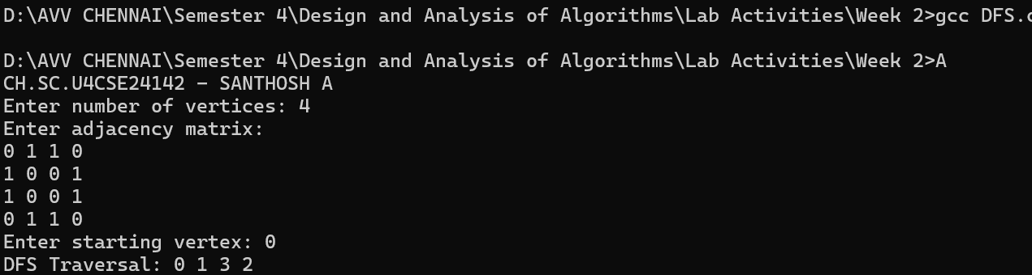
Space Complexity: O(V)
Time Complexity: O(V+E)
Justification:
- The recursion stack can grow upto V levels and the visited [ ] array stores V entries. Hence the Space Complexity is O(V).
- DFS recursively explores every vertex and inspects all edges exactly once through the adjacency list. Hence the Time Complexity is O(V+E).

